LIGHT BITES
Eat In or out
Selection of Danish Pastries £2.40 £2.00
Bacon roll £4.90 £3.90 with melted cheese & fried egg £5.90 £4.70
Ham and cheese croissant £4.00 £3.20
Cheese and tomato croissant £4.00 £3.20
Sourdough with avocado, tomato, £6.90 £5.50
2 poached eggs
Sourdough with smoked salmon, £7.50 £6.00
avocado, 2 poached eggs
Staffordshire Oatcakes with £6.50 £5.20
bacon, cheese, fried egg £6.50
BREAKFAST & BRUNCH SERVED ALL DAY
Three eggs omelette with: Mushrooms, onions & cheese £6.00 £4.80
Spinach & feta £6.00 £4.80
Smoked salmon & dill £6.50 £5.20
Smoked ham & cheese £6.00 £4.80
Three free range scrambled eggs served on toasted English muffin with
Crispy bacon and maple syrup £6.90 £5.50
Mushrooms & sautéed onions £6.50 £5.20
Tomatoes & avocado £6.50 £5.20
Plain £4.90 £3.90
On The Hoof big breakfast £9.50 £7.60
2 slices of bacon, 2fried eggs,
2 sausages, sautéed potatoes and baked beans
On The Hoof big veggie £9.00 £7.20
Grilled haloumi, 2 fried eggs, mushrooms, sautéed potatoes, avocado and baked beans
On The Hoof big vegan £9.00 £7.20
Grilled tofu, mushrooms, bean hash, sautéed sweet potatoes, avocado and baked beans
2 Poached Eggs on toasted English muffin served with hand made fresh hollandaise sauce
Eggs Benedict with bacon £6.90 £5.90
Eggs Royale with smoked salmon £7.50 £6.50
Eggs Florentine with spinach £6.50 £5.50

FOOD MENU

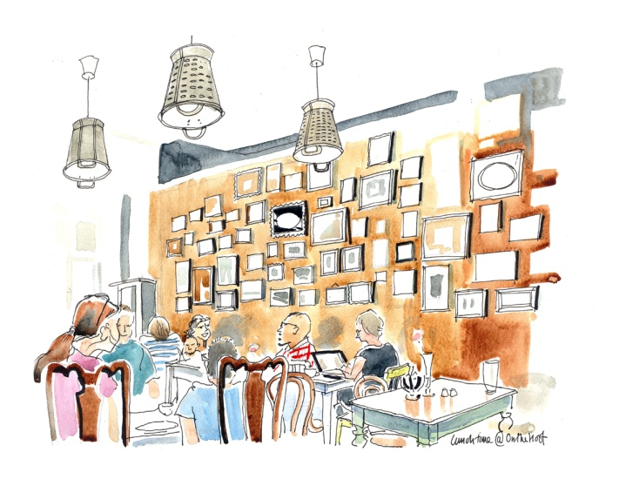

TRADITIONAL LUNCH CHOICES SERVED FROM 12PM
Eat In or out
Soup of the day with toast £5.50 £4.50
Homemade salmon fishcakes £7.50 £6.00
served with hollandaise sauce and mixed leaf salad
Salad of the day £7.50 £6.00
Bell peppers stuffed with mince turkey £8.50 £6.80
mushrooms & rice
Meat Lasagne £8.50 £6.80
VEGETERIAN & VEGAN
Spicy bean burger served £8.50 £6.80
with fries or salad
Bell peppers stuffed with butternut £8.50 £6.80
squash, red onion, mushrooms, beans & courgettes
Vegetable Lasagne £8.50 £6.80
Five vegetable gyozas 10pcs £6.00 £5.00
served with Edamame 15pcs £8.00 £6.50
Sauerkraut & mushrooms stew £8.50 £6.80
served with sourdough
THE BURGERS served with French fries or mixed salad
Classic beef burger, gherkins £8.50 £6.80
red onions, tomatoes
Hot beef burger served with jalapenos £8.50 £6.80
chilli jam, gherkins & red onions
The Full Monty beef burger served £10.00 £8.00
with cheese, bacon, gherkin & tomatoes
Skinny beef burger served with £8.50 £6.80
avocado & mixed salad
French fries £3.50 Sweet potato fries £4.00
Add: bacon £1.00 sausage £1.50 avocado £1.50 egg £1.00 mushrooms £1.00 cheese £1.00 toast £1.00 haloumi £1.00 smoked salmon £2.00 sautéed potatoes £2.00 black pudding £1.00
All prices include VAT
Service not included
Management advises that food prepared here may contain traces of peanuts, tree nuts, soya, milk, wheat, shellfish
TEAS AND COFFEES
Selection of Monmouth espresso based coffees
Latte/Cappuccino £2.60
Flat white/Filter £2.50
Black/Espresso £2.30
Mocha/Chai Latte £2.80
Hot Chocolate £2.60
Iced Coffee £2.80
Extra shot/Syrup 50p
Soya/oat/almond/coconut milk 30p
Babyccino £1.00
Tea/Earl Grey £2.20
Herbal Tea £2.60
SELECTION OF CAKES £2.90/£3.50
FRESH FRUIT JUICES £2.90
Choose mixed or single fruit from oranges, carrots, apples, beetroot and ginger
FROZEN FRUIT SMOOTHES £2.90
Tropical: mango, pineapple, banana
Mixed Berries: strawberries, blueberries, blackberries, blackcurrants
Peach Melba: peach, mango, banana
Add extra fruit, coconut water, kefir 50p
MILKSHAKES £3.90
Any two of our ice cream flavours
Add blueberries/strawberries £4.50
bananas, mixed berries, pina colada
Oreo, Aero Mint, Crunchie, Bounty, Snickers
Kinder Bueno, Milky Bar, Maltesers, Daim
ICE CREAM
1 scoop £2.50
2 scoops £3.70
3 scoops £5.00

DRINKS & DESSERT MENU

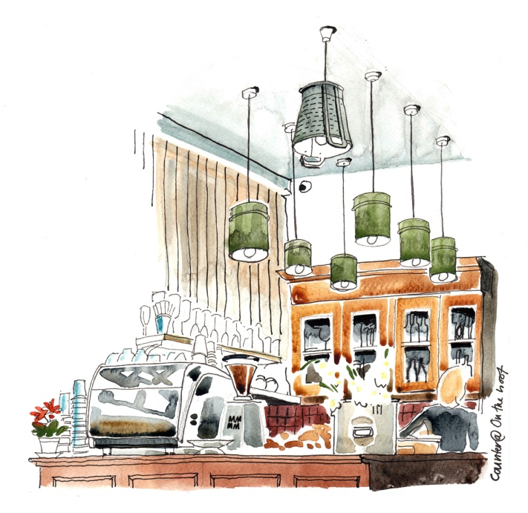

Italian Gelato flavours:
vanilla, chocolate, strawberry, pistachio, bubble gum, cookies & cream, mint choc, mango
ICE CREAM DESSERTS
OREO VANILLA £5.50
scoop of vanilla, chocolate and cookies and cream with Oreo biscuit, chocolate sauce and whipped cream
MARINGUE FANTASY £5.50
scoop of vanilla, mango and strawberry with strawberry sauce and meringue sauce
CHOCOLATE KING £5.90
scoop of vanilla, chocolate and chocolate @ orange with chocolate sauce, walnuts and whipped cream
COOL MINT £5.50
Scoop of mint choc, vanilla and chocolate with chocolate sauce and whipped cream
AFFOGATO £5.90
Scoop of vanilla, chocolate and cookies & cream with a shot of espresso and whipped cream
ADVOCAAT £6.50
scoop of vanilla and chocolate with walnuts, raisins and shot of advocaat liqueur
BAILEYS £6.50
scoop of vanilla and chocolate with walnuts, raisins and shot of Baileys liqueur
SOFT DRINKS
Still/sparkling water £2.10
San Pellegrino orange/lemon £2.10
Coke/diet coke £2.10
Ginger beer/Rose lemonade £2.50
SELECTION OF HOUSE WINE, BEER, SPIRITS AND MIXERS AVAILABLE

