LIGHT BITES

Selection of Danish Pastries £2.00
Bacon roll £4.90 with melted cheese & fried egg £5.90
Ham and cheese croissant £3.50
Cheese and tomato croissant £3.50
Sourdough with avocado, tomato, £6.90
2 Clarence Court poached eggs
Sourdough with smoked salmon, £7.50
avocado, 2 Clarence Court poached eggs
Staffordshire Oatcakes with £6.50
bacon, cheese, Clarence Court fried egg

Toasted Sourdough Sandwiches
Ham and cheese £4.90
Goat cheese, balsamic, roasted peppers £4.90
Mozzarella, fresh basil, chilli pesto £4.90
Cheddar and tomato £4.90
Milano salami, cheddar, chilli pesto, £5.50
sun dried tomatoes

BREAKFAST & BRUNCH SERVED ALL DAY

On The Hoof big breakfast £9.50
2 Clarence Court fried eggs, 2 slices of bacon,
2 sausages, sautéed potatoes and baked beans
On The Hoof big veggie £9.00
2 Clarence Court fried eggs, grilled haloumi, mushrooms, sautéed potatoes and avocado
On The Hoof breakfast £6.90
Clarence Court fried egg, bacon, sausage, sautéed potatoes and baked beans
On The Hoof veggie £6.90
Clarence Court fried egg, grilled haloumi, mushrooms, sautéed potatoes and avocado

Please, note that our Clarence Court Buford Brown eggs are available to buy here for £2.50 per half a dozen
FOOD MENU

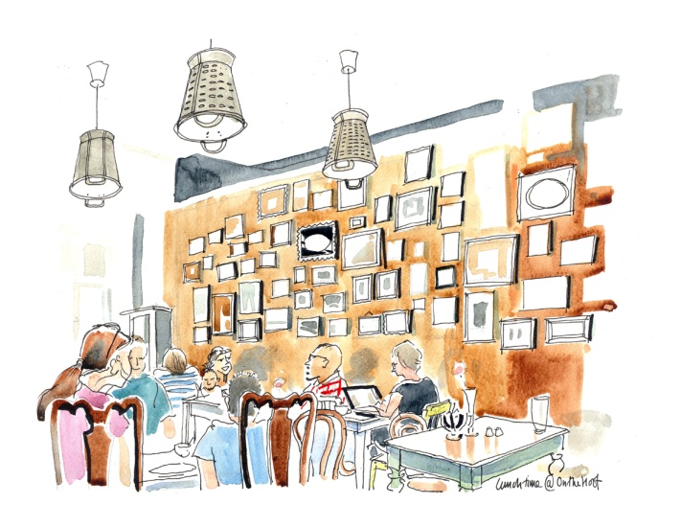
2 Poached Clarence Court Eggs on toasted English muffin served with hand made fresh hollandaise sauce
Eggs Benedict with bacon £6.90
Eggs Royale with smoked salmon £7.50
Eggs Florentine with spinach £6.50
Three eggs omelette with: Mushrooms, onions & cheese £6.00
Spinach & feta £6.00
Smoked salmon & dill £6.50
Smoked ham & cheese £6.00
Three free range scrambled eggs served on toasted English muffin with
Crispy bacon and maple syrup £6.90
Mushrooms & sautéed onions £6.50
Tomatoes & avocado £6.50
Plain £4.90
American Pancakes Sunday 9am - Noon
Three pancakes with bacon & maple syrup £7.50
Three pancakes with toffee & mixed fruit £6.90

Service not included All prices include VAT

TRADITIONAL LUNCH CHOICES SERVED FROM 12PM

Soup of the day with toast £5.50
Manomasa tortilla crisps, home tapenade £5.50
and mixed olives
Homemade salmon fishcakes £7.50
served with hollandaise sauce and mixed leaf salad
Meat Lasagne £8.50
Dish of the day offering variety and value £6.90
Please, ask member of staff for details
VEGETERIAN & VEGAN
Spicy bean burger served with fries or salad £8.50
Vegetable Lasagne £8.50
Vegetable gyozas 6pcs £6.00
10pcs £8.00
THE BURGERS served with French fries or mixed salad
Classic beef burger, gherkins £8.50
red onions, tomatoes
Hot beef burger served with jalapenos £8.50
chilli jam, gherkins & red onions
The Full Monty beef burger served £10.00
with cheese, bacon, gherkin & tomatoes
Skinny beef burger served with £8.50
avocado & mixed salad
French fries £3.50
Sweet potato fries £4.00
Extras:
Add: bacon £1.00 sausage £1.50 avocado £1.50 egg £1.00 mushrooms £1.00 cheese £1.00 toast £1.00 haloumi £1.00 smoked salmon £2.00 sautéed potatoes £2.00 baked beans £1.00

Management advises that food prepared here may contain traces of peanuts, tree nuts, soya, milk, wheat, shellfish

TEAS AND COFFEES
Selection of Monmouth espresso based coffees
Latte/Cappuccino £2.60
Flat white/Filter £2.50
Black/Espresso £2.30
Mocha/Chai Latte £2.80
Hot Chocolate £2.60
Iced Coffee £2.80
Baileys Latte £5.50
Baileys Hot Chocolate £5.50
Extra shot/Syrup 50p
Soya/oat/almond/coconut milk 30p
Babyccino £1.00
Tea/Earl Grey £2.20
Herbal Tea £2.60

SELECTION OF HOME MADE CAKES £2.90/£3.50

FRESH FRUIT JUICES £2.90
Choose mixed or single fruit from oranges, carrots, apples, beetroot and ginger

FROZEN FRUIT SMOOTHES £2.90
Tropical: mango, pineapple, banana
Mixed Berries: strawberries, blueberries, blackberries, blackcurrants
Peach Melba: peach, mango, banana

DRINKS & DESSERT MENU

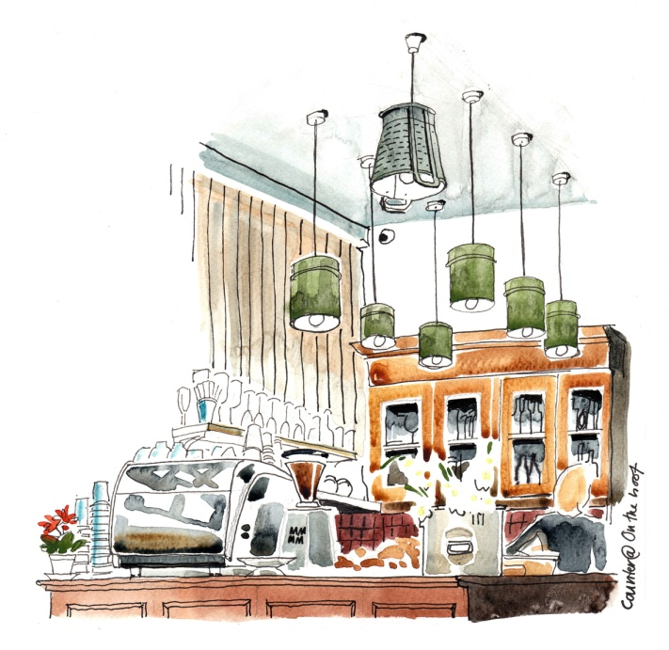

MILKSHAKES £3.90
Any two of our ice cream flavours
Add blueberries/strawberries £4.50
bananas, mixed berries, pina colada
Oreo, Crunchie, Snickers, Kinder Bueno

ICE CREAM
1 scoop £2.50
2 scoops £3.70
3 scoops £5.00

Italian Gelato flavours:
vanilla, chocolate, strawberry, pistachio, bubble gum, cookies & cream, mint choc, mango

SOFT DRINKS
Still/sparkling water £2.10
San Pellegrino orange/lemon £2.10
Coke/diet coke £2.10
Ginger beer/Rose lemonade £2.50

SELECTION OF HOUSE WINE, BEER, SPIRITS AND MIXERS AVAILABLE

